**Stability Analysis**

For the stability of the aircraft, two of the most important concepts are the place of the center of gravity and tail volume. The center of gravity needs to be in front of the center of lift for stability. The tail volume represents the effectiveness of tail and it was chosen to be (ne kadar ve need o kadar olduğunu açıklamak lazım.) Theni the tail area was calculated using tail volume and the distance of the tail.

After the tail is designed and the plane inertias are calculated, the dynamic stability analysis of the aircraft is done using XFLR5. During the analysis the damping ratios and frequencies of the natural aerodynamic modes are calculated as eigenvectors and eigenvalues. The real parts of these eigenvalues are related to the damping coefficient and their imaginary parts correspond the frequencies. The resulting eight modes can be divided into, four longitudinal and four lateral modes, some of which are symmetric.

**Longitudinal Modes**

The longitudinal modes are two symmetric phugoid modes and two symmetric short period modes. The phugoid is a long period mode that is caused by the exchange of kinetic and potential energy and it is usually lightly damped. (Belki ayrıntılı açıklama) For our plane the damping ratio (zeta) of this mode is calculated to be 0,033 and the damped natural frequency is 0,8958 Hz. Modal response is shown in Figure X.1.

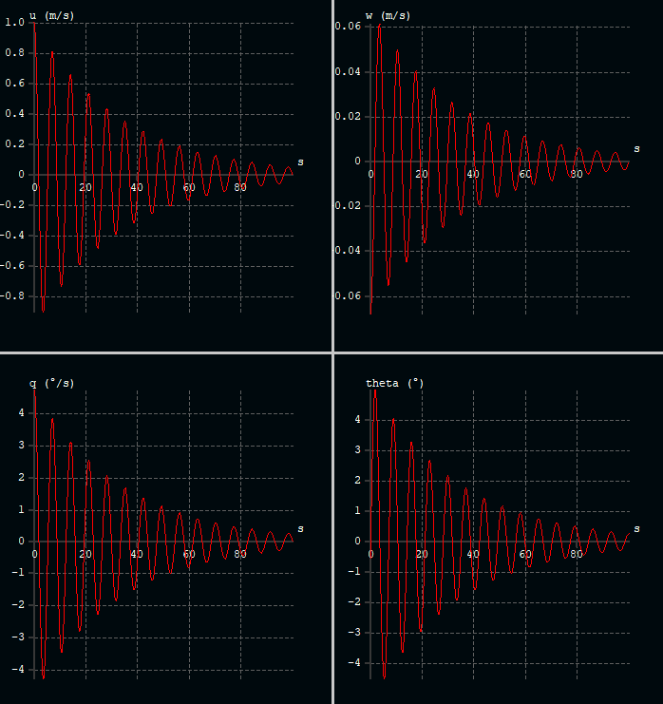

Figure X.1. Phugoid mode, modal response.

The other longitudinal mode is the short period mode. This mode is related to pitch rate and vertical movement. It is usually high frequency and damped well. (Belki ayrıntılı açıklama) For our plane the damping ratio (zeta) of this mode is calculated to be 0,553 and the damped natural frequency is 11,569 Hz. Modal response is shown in Figure X.2.

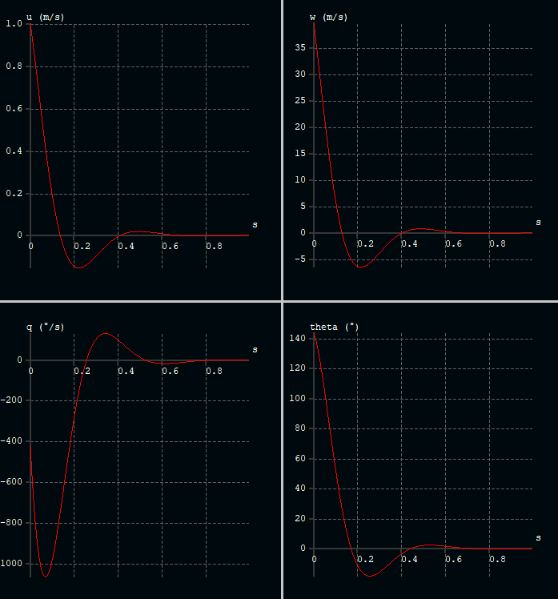

Figure X.2. Short longitudinal mode, modal response.

**Lateral Modes**

The lateral modes are one spiral mode, one roll damping and two symmetric Dutch roll modes. The spiral is primarily a change in heading and it is a non-oscillatory and slow mode and it is usually unstable. This mode is also unstable for our plane as can be see from the modal response in Figure X.3. Although it is an unstable mode, this is usually corrected by the pilot unconsciously by the pilot since it is very slow. For our plane, the doubling time is calculated to be 4,227s and this will be corrected by the flight controller.

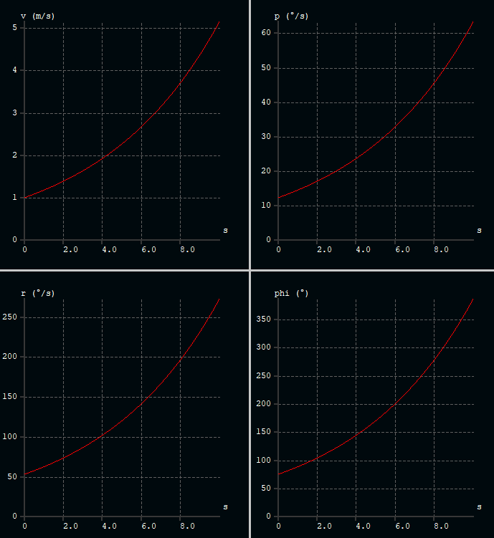

Figure X.3. Spiral mode, modal response.

Another lateral mode is roll damping which is related to a change in roll. This mode is non-oscillatory and usually fast. For our plane the halving time is calculated to be 0,055 s. The modal response of this mode is shown in Figure X.4.

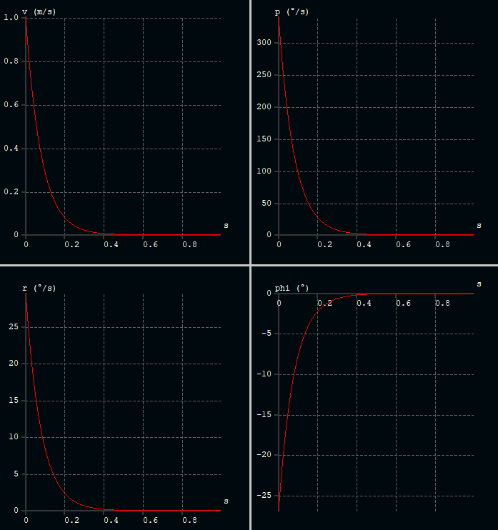

Figure X.4. Roll damping mode, modal response.

Lastly there is the Dutch roll mode which is a combination of roll and yaw change with a 90-degree phase difference. This mode is usually lightly damped. (Belki ayrıntılı açıklama) For our plane the damping ratio (zeta) of this mode is calculated to be 0,165 and the damped natural frequency is 4,2172 Hz. Modal response is shown in Figure X.5.

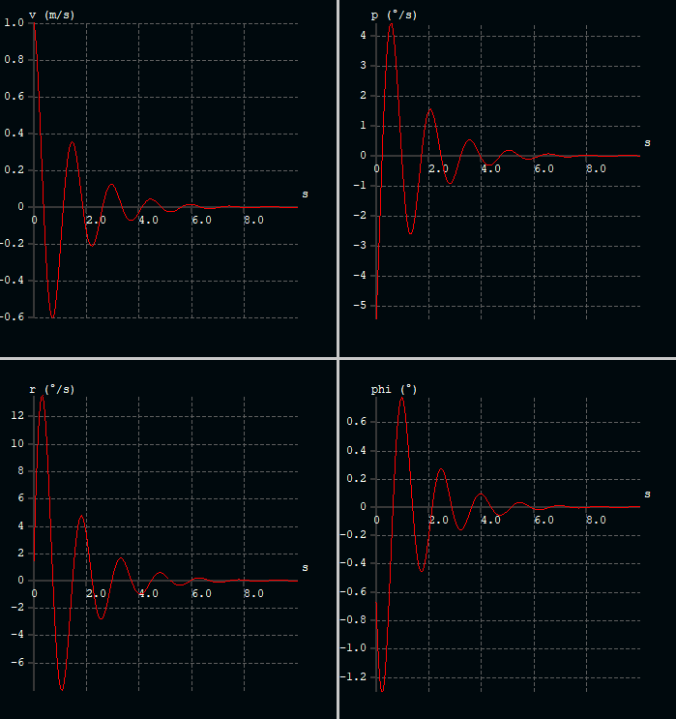

Figure X.5. Dutch roll mode, modal response.